Year 10 Science  Task 2: DNA Research  Science Inquiry; Human Endeavour 10% | Name:
 | Due:
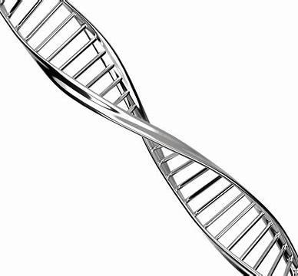

Part 1: In class
As a class, brainstorm the kind of questions that people might have about DNA.

Part 2: Individually
Identify your target audience.
Select 5 questions to research.
_________________________________________________________________________________________________________________________________________________________________________________________________________________________________________________________________________________________________________________________________________________________________________________________________________________________________________________________________________________________________________________________________________________________________________________________________________________________________________________________________________________

- Make a dot point summary to answer the questions, collect diagrams and keep a list of references.

- While you are researching, write down 5 unfamiliar words, then find their meaning (keep references) and write a definition in your own words.

- Use the information you have collected to make one of the following

- a webpage of FAQs (offline)
- an information brochure for high school students
- a children’s story or book
- a letter to householders requesting donations to the “gene bank” foundation
- an advertisement for DNA testing

You will need to hand in
- your hand written notes as dot points
- your bibliography
- your glossary of definitions
- webpage/brochure/story/letter/advertisement

Marking guide /25

 | 1 | 2 | 3 | 4 | 5
Research and notes | 1 question  answered | 2 questions  answered | 3 questions  answered | 4 questions  answered | 5 questions answered
 | Cut and paste, whole sections or irrelevant information | Cut and paste, whole sentences copied | Dot point but not hand written | Dot points hand written but whole sentences or poorly organised | Hand written, dot points used correctly and organised
Bibliography | 2 or less references; incorrect format | 3 or more references; correct format
Glossary | Less than 3 words; definitions are cut and paste | 4 words; defined out of context or not suitable wording for target audience | 5 words, defined in context and in suitable wording for target audience
Web FAQ/  Brochure/Book/Letter or Advertisment | Uses suitable text and layout convention; | Suitable for target audience
 | One or two diagrams only | 3 or more diagrams
 | Cluttered, unclear or hard to read; incomplete | Visually appealing but lacking in content or clarity; too much or too little text or graphics | Visually appealing, good use of text and graphics | Visually appealing, good use of graphics, text, captions and font/colour
 | Only a few spelling or grammar mistakes | No spelling or grammar mistakes

